**Practical No: 1** Ninad Karlekar 22306A1012 Date: 17/04/2023

**Aim: Configure IP SLA tracking and path control topology.**

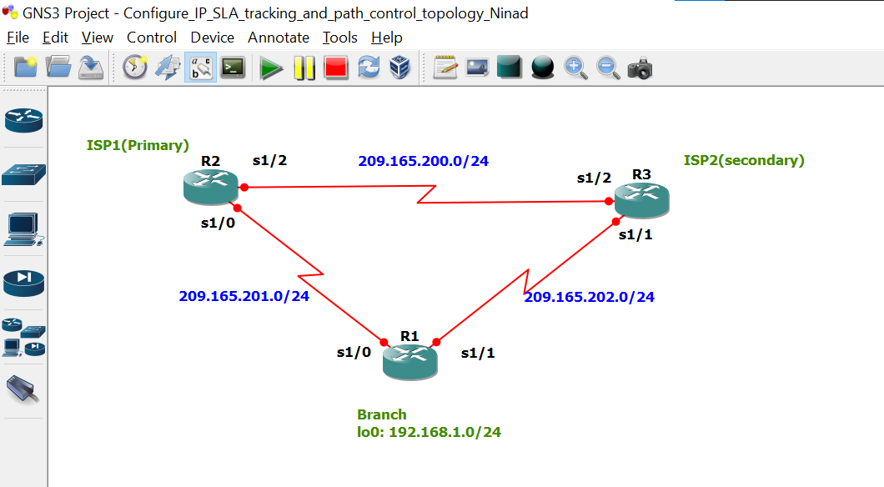

Take 3 routers -> Configure -> slots -> NM-4T

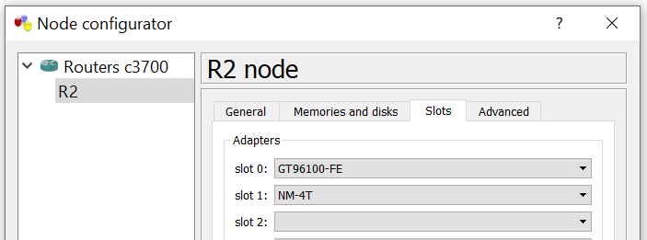

**Task 1: Configure IP SLA using GNS3**

**On router 1 console**

R1 #

R1 # conf t

R1(config) # int s1/0

R1(config-if) # ip add 209.165.201.1 255.255.255.0

R1(config-if) # no sh

R1(config-if) #

R1(config-if) # int s1/1

R1(config-if) # ip add 209.165.202.1 255.255.255.0

R1(config-if) # no sh

R1(config-if) #

R1(config-if) # int lo0

R1(config-if) # ip add 192.168.1.1 255.255.255.0

R1(config-if) #

R1(config-if) # do sh ip int br | include up

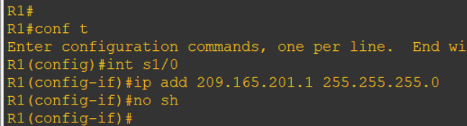

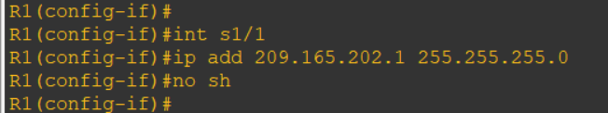

**On router 2 console**

R2 # conf t

R2(config) # int s1/0

R2(config-if) # ip add 209.165.201.2 255.255.255.0

R2(config-if) # no sh

R2(config-if) #

R2(config-if) # int s1/2

R2(config-if) # ip add 209.165.200.2 255.255.255.0

R2(config-if) # no sh

R2(config-if) #

R2(config-if) # do sh ip int br | include up

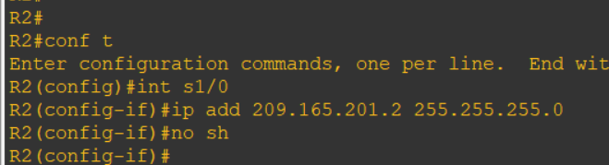

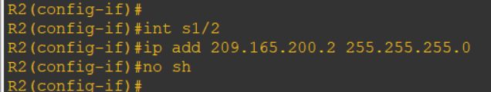

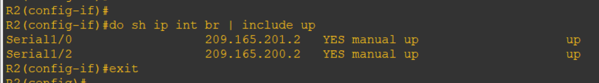

**On router 3 console**

R3 # conf t

R3(config) # int s1/1

R3(config-if) # ip add 209.165.202.3 255.255.255.0

R3(config-if) # no sh

R3(config-if) #

R3(config-if) # int s1/2

R3(config-if) # ip add 209.165.200.3 255.255.255.0

R3(config-if) # no sh

R3(config-if) #

R3(config-if) # do sh ip int br | include up

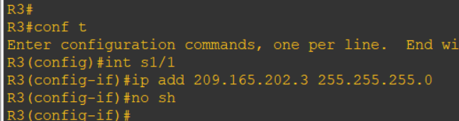

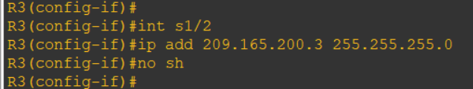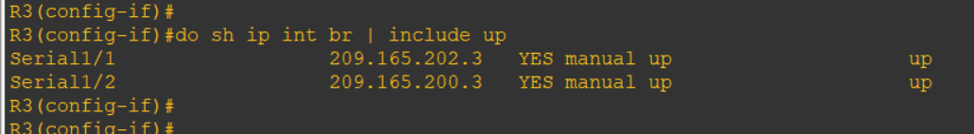

**Task 2: Configure static routing on branch router and dynamic routing using eigrp**

**On router 1 console**

R1 # conf t

R1(config) # ip route 0.0.0.0 0.0.0.0 209.165.201.2

R1(config) #

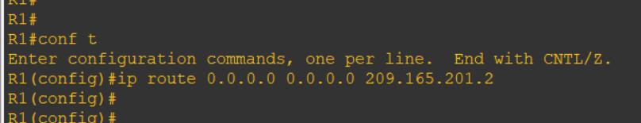

**On router 2 console**

R2(config) # router eigrp 1

R2(config-router) # network 209.165.200.0 0.0.0.255

R2(config-router) # network 209.165.201.0 0.0.0.255

R2(config-router) # no auto-summary

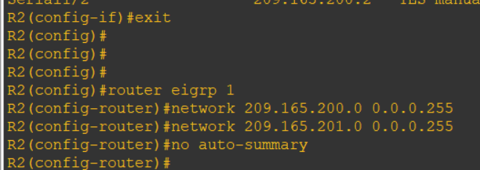

**On router 3 console**

R3(config) # router eigrp 1

R3(config-router) # network 209.165.200.0 0.0.0.255

R3(config-router) # network 209.165.202.0 0.0.0.255

R3(config-router) # no auto-summary

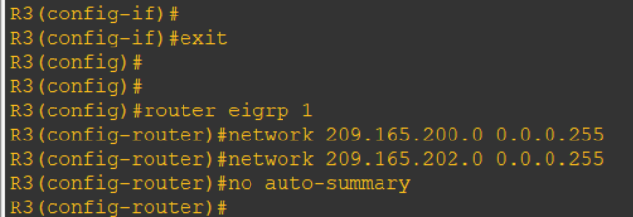

**On router 2 console**

R2(config-router) # exit

R2(config) # ip route 192.168.1.0 255.255.255.0 209.165.201.1

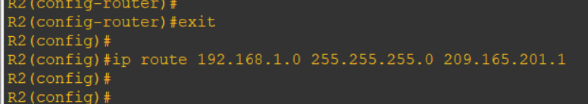

**On router 3 console**

R3(config-router) # exit

R3(config) # ip route 192.168.1.0 255.255.255.0 209.165.202.1

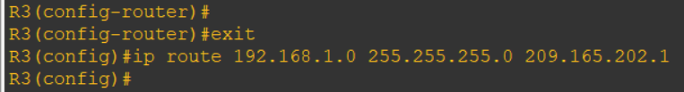

**Ping other routers**

R1(config) # do ping 209.165.200.3

R3(config) # do ping 209.165.201.1

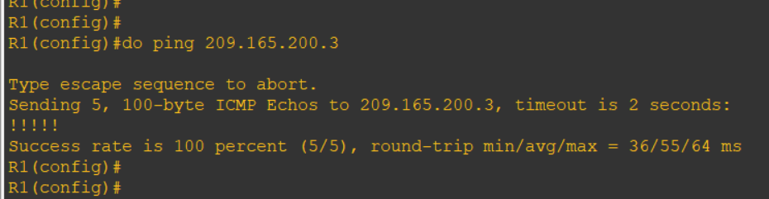

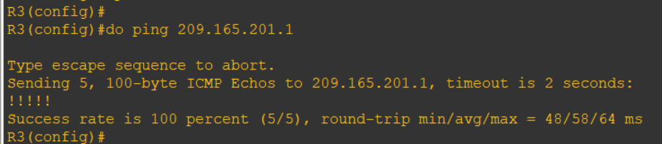

**Ping other routers**

R2(config) # do ping 192.168.1.1

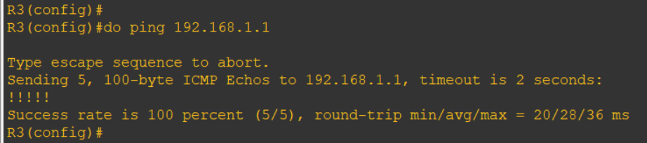

**Give hostname**

R1(config) # hostname r1-branch

R2(config) # hostname r2-isp1

R3(config) # hostname r3-isp2

**Task 3: Configure IP SLA probes at branch router**

**On router 1 console**

r1-branch(config) # ip sla 11

r1-branch(config-ip-sla) # icmp-echo 209.165.201.2

r1-branch(config-ip-sla-echo) # frequency 10

r1-branch(config-ip-sla-echo) # exit

r1-branch(config) #

r1-branch(config) # ip sla schedule 11 life forever start-time now

r1-branch(config) #

r1-branch(config) # do sh ip sla configuration 11

